6.

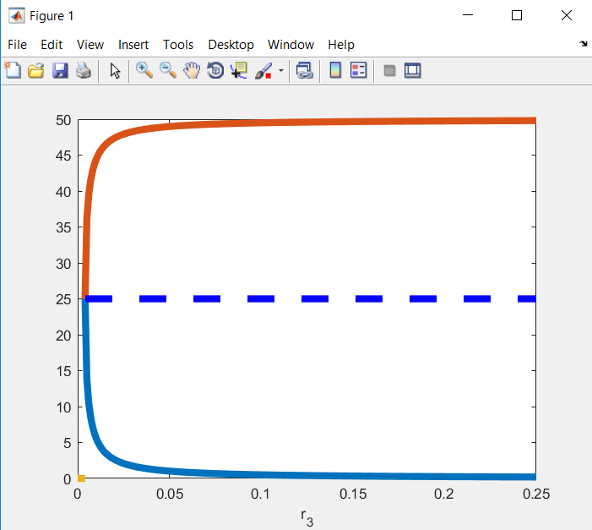

7.

See 3.14 and 3.15

With the deterministic description of the system, we found that the deterministic ODEs do not provide an exact description of the mean behaviour of the system. Moreover, with second-order (or higher-order) reactions; we do not obtain a closed evolution equation for the mean, we need to use moment closure to obtain an approximate set of equations.

In particular, in systems with many favourable steady states SSA gives results which cannot be obtained from the deterministic model.

9.

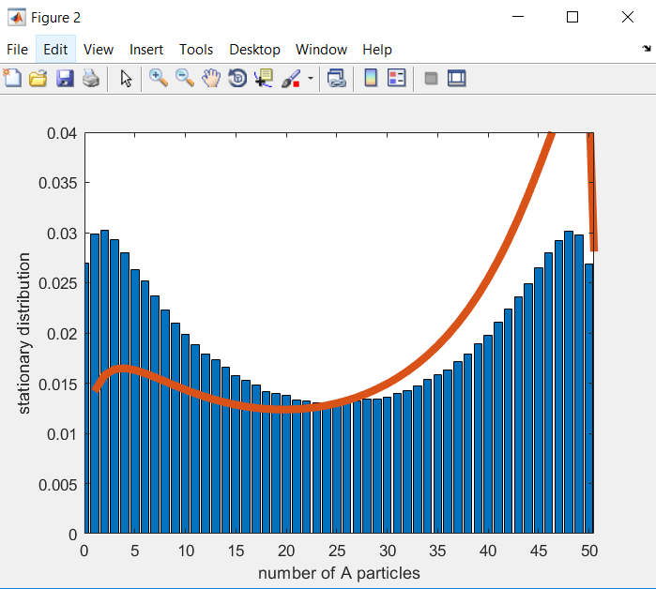

See 5.3

And beginning of chapter 6…for which the deterministic description is non-linear, we found that the deterministic ODEs do not provide an exact description of the mean behaviour of the system.

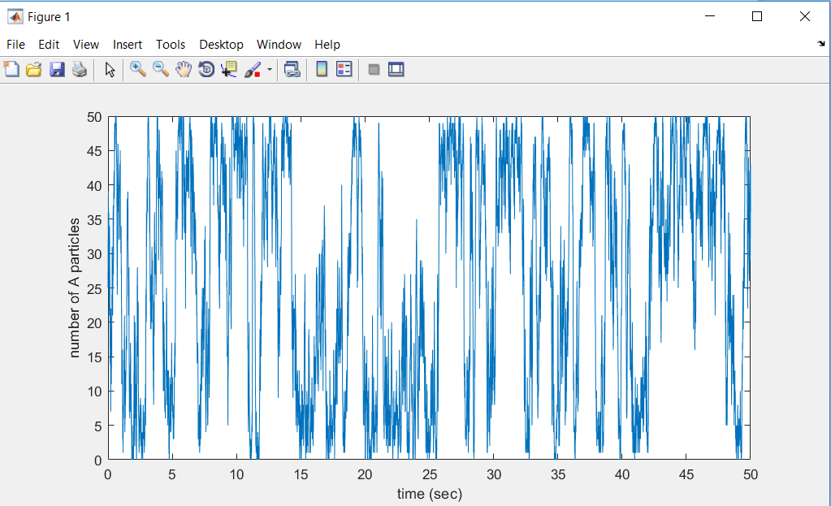10.

As we can see in the figure, the number of A particles changes dramatically between 0 and 50.

If we consider the figure in question 6 and we realise that k3onu2 = 0.005, we see the huge bifurcation between the two values 0 and 50 of A, fact which explains this figure.

11.

If we change the parameter k3onu2 to 0.003, because of the result from question 5, the two stable states A2 and A3 disappear.